**Backend – Fast API with SQL Alchemy**

1. Create different project structure consists like this:

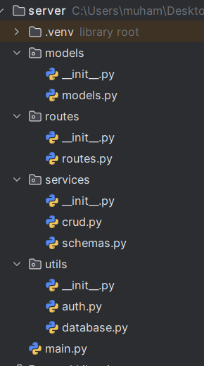

1. Start with database configuration with mySQL with your backend in the **utils/database.py** module for following code:

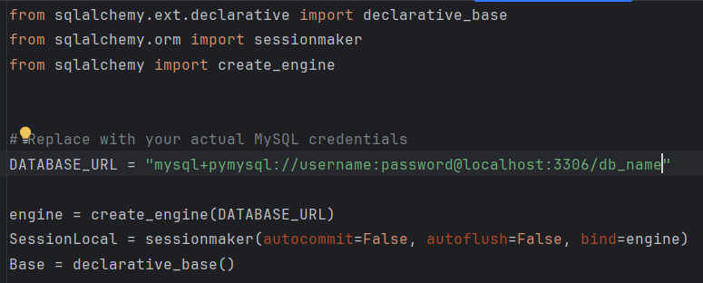

1. Now start create your model required for the project in my application need to create for customers, bank and bank account model created in the **models/models.py** module:

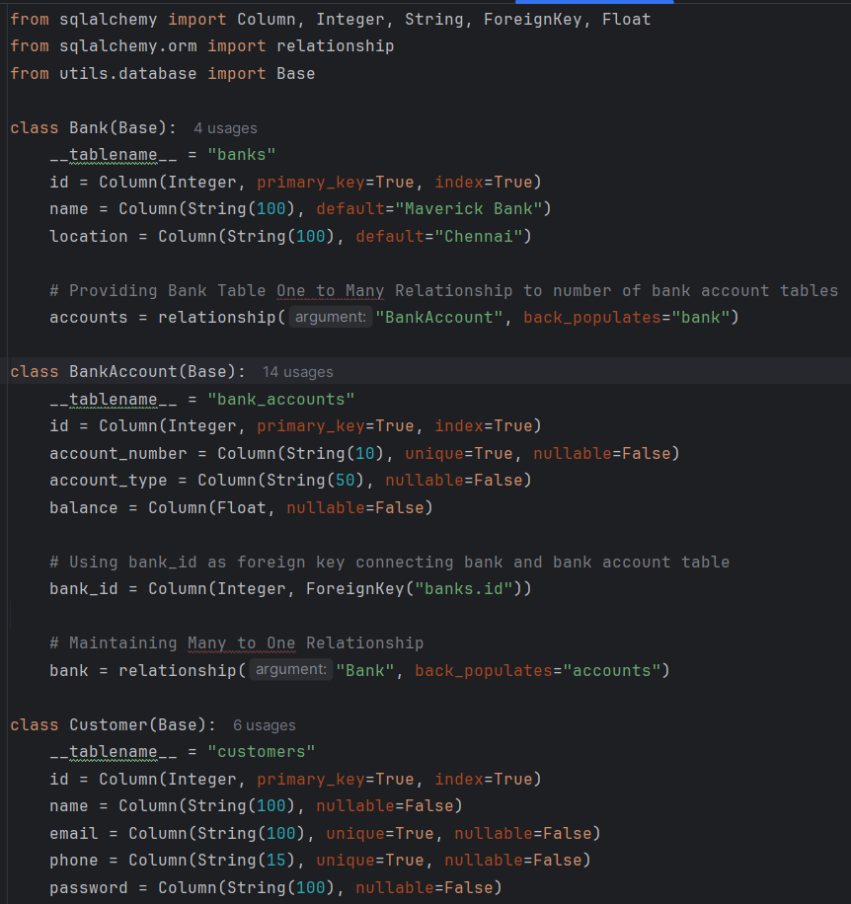

1. Create **utils/auth.py** for encryption of password and returning access token of the user while login and code contains:  
   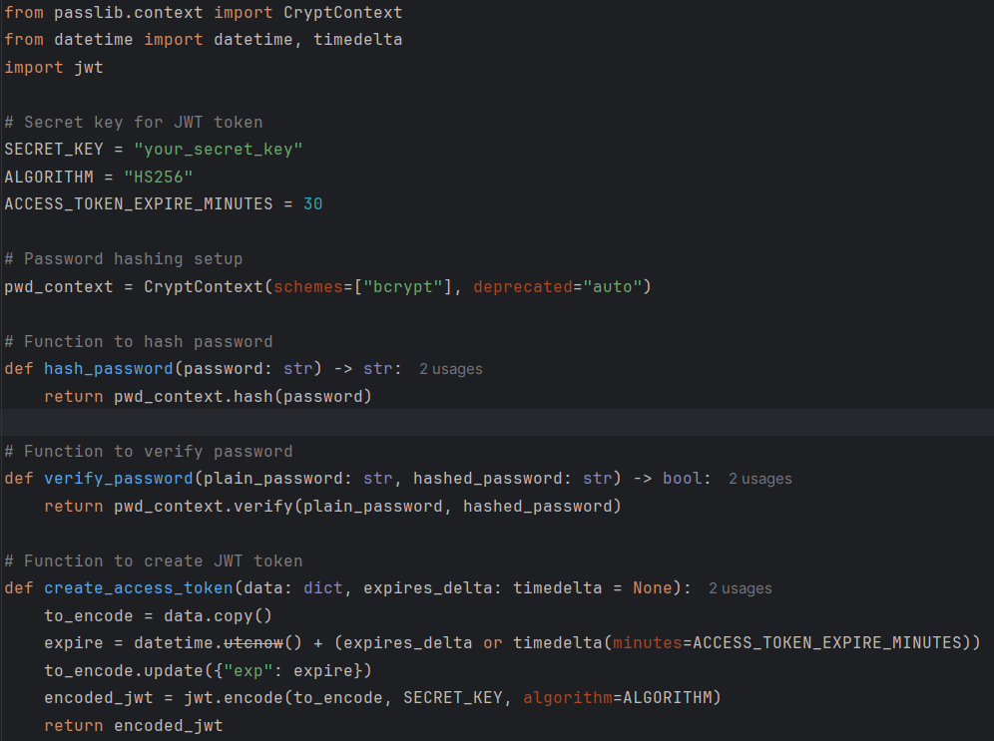
2. Now create schemas for all required operations in the applications and it is provided in **services/schemas.py**

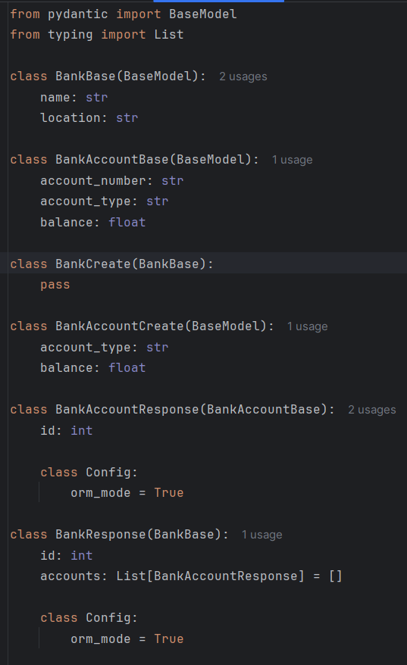

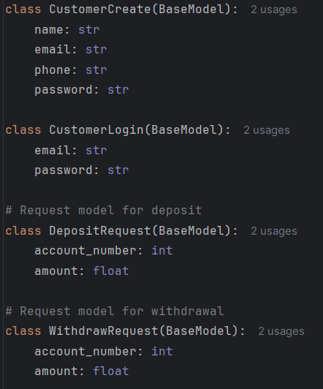

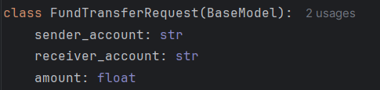

1. Implement code for CRUD operation on **services/crud.py** module:

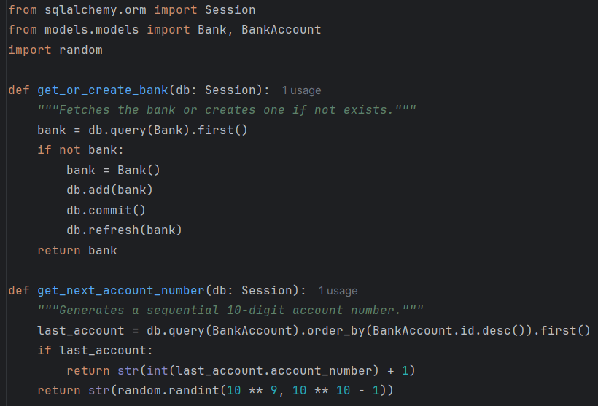

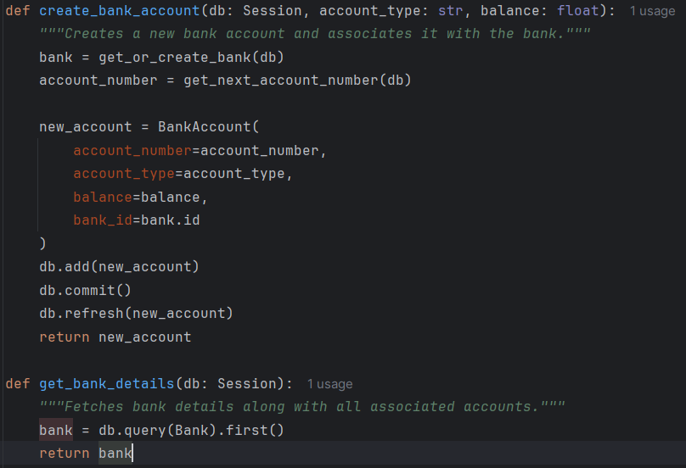

1. Create necessary routes of crud operation in **routes/routes.py** module:

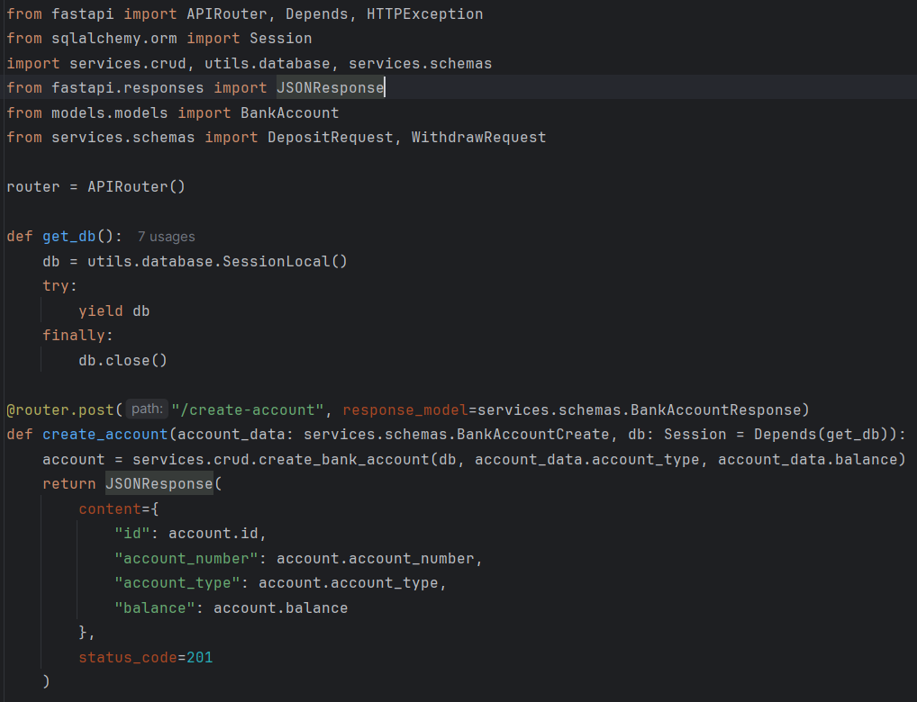

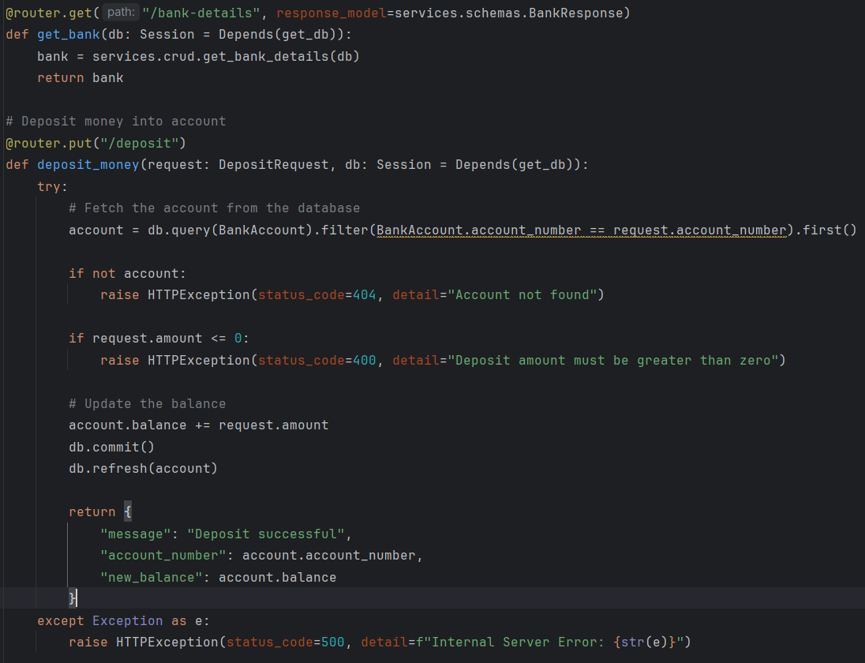

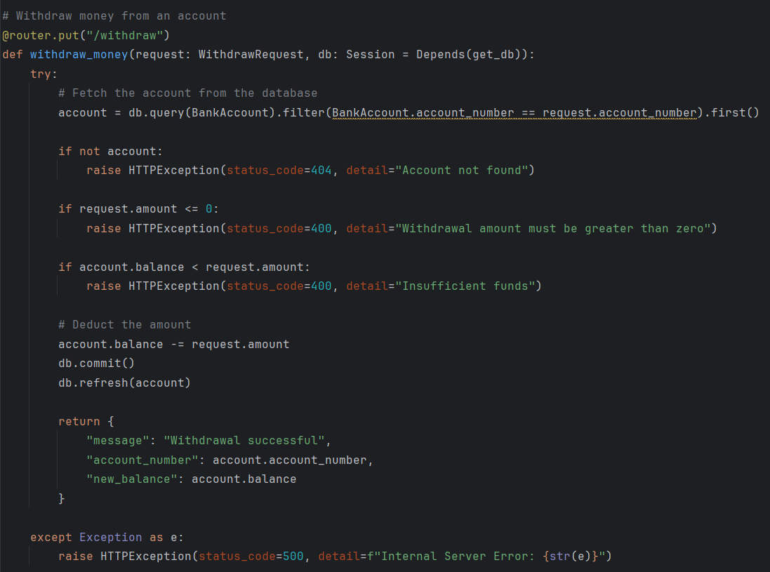

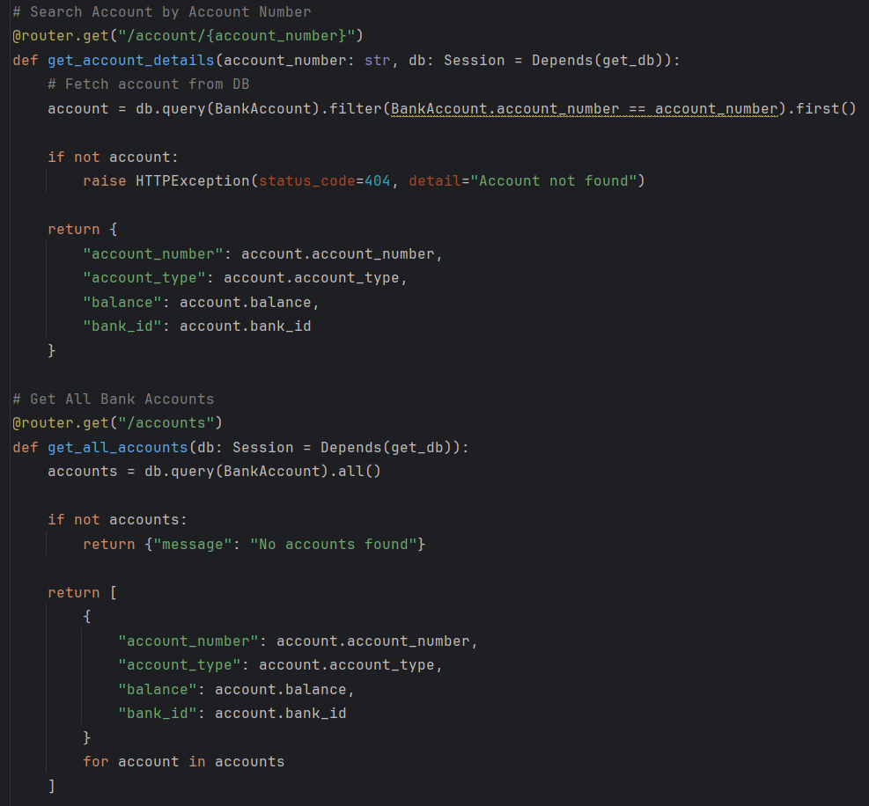

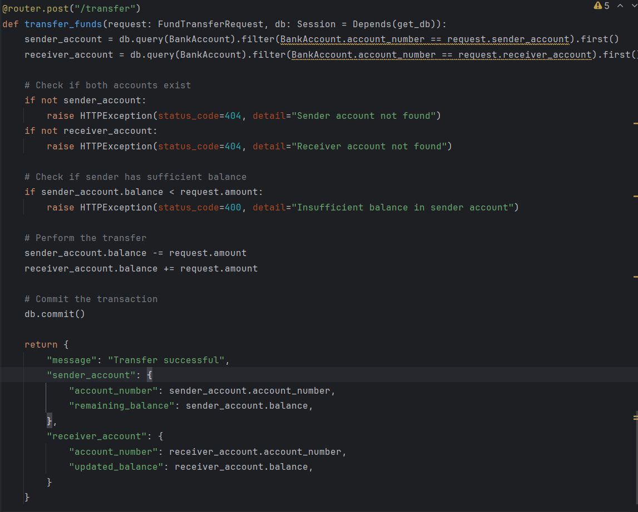

1. Now implement all the routes and signup, login routes in **main.py** module:

